# Developed By

* Monojit Laha (monojit.Laha@cognizant.com)
* Swadhin Mukherjee (Swadhin.mukherjee@cognizant.com)

# Project Diagram

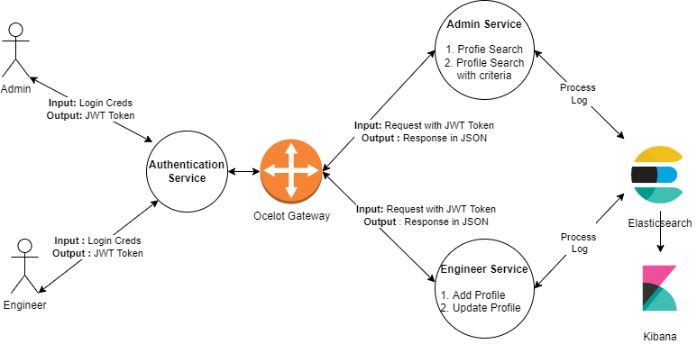

# Git Repos

* **Authentication Service -** <https://github.com/monojitlaha/jwt-authentication-service.git>
* **Ocelot Gateway Service** - <https://github.com/monojitlaha/skill-tracker-apigw.git>
* **Admin & Engineer Service** - <https://github.com/monojitlaha/skill-tracker-service.git>

# Process to Run and Validate

* **Run Docker Compose file for ELK** –  
    
  
* **Unzip and Import Postman collection**   
    
  
* **Run Authentication Service, Ocelot Gateway Service and Admin & Engineer Service**